A.Y 2022-23 Even Sem Date:23/6/23

Report on PSR Activity: Super AI Community Stakeholder Connect

Objective:
The objective of Super AI Community Stakeholder Connect is to build students’ knowledge, skill and strengthen the domain by inclusion of Industry Academia/ Alumni expert sessions/ Peers Learning Sessions, competitions, exhibitions and collaborative research activities.
Following activities are done during Academic Year 2022-23 Even Semester:
Activity 1: Chatgpt Competition
Date: 16th February 2023
Time: 3:30pm to 5:30pm

Participants: ST and TT students

Objectives:
- To enhance research and critical thinking skills
- To gain hands-on experience with AI language models
- To promote effective communication skills

Description:

Super AI Stakeholder Connect conducted a competition on “ChatGpt”.In the ChatGPT competition, participants were provided with a set of questions to find out the answers using ChatGPT. The objective was to utilize the capabilities of ChatGPT to retrieve accurate information. Participants delved into the world of AI, asking questions and receiving responses from the model. Their task was to analyze and evaluate the answers to determine their accuracy and relevance. Points were awarded based on the accuracy of their answers.

Participation Analysis:

Sr. No. | Class | No. of Students
1 | ST | 21
2 | TT | 7
Total: |  | 28

Activity Photo:

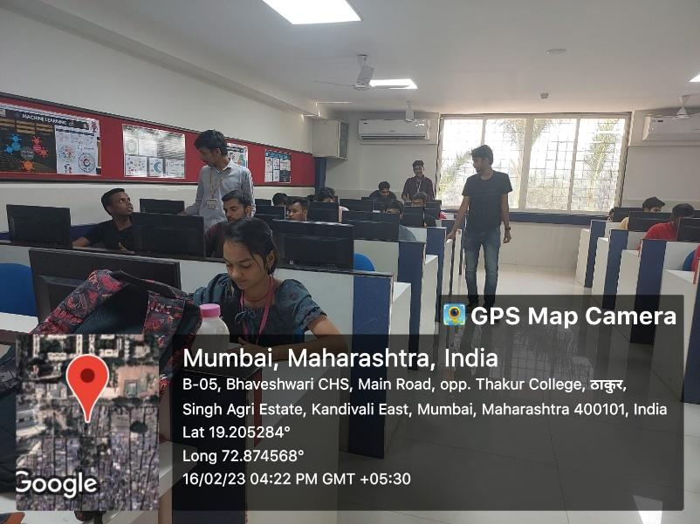

Feedback Analysis:

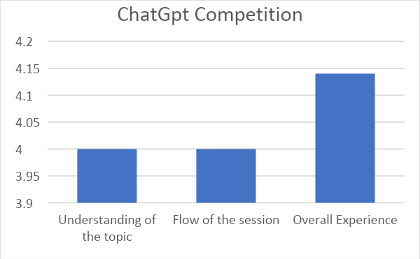

Outcome:
Students were able to enhance their information retrieval abilities and gain practical experience in leveraging AI language models.
PO Attained: PO1,PO2,PO3,PO5,PO9,PO10
Activity 2: The Art of Time Series Forecasting and Analytics

Date: 9th March, 2023

Time: 3:30 PM-5:30 PM

Participants: ST and TT Students

Objectives:
- To provide insights and knowledge about time series forecasting and analytics.
- To impart the best practices for creating accurate forecasts.
- To equip attendees with the skills to effectively utilize time series data in their analytical work.

Description:
Super AI Stakeholder Connect conducted a seminar on "The Art of Time Series Forecasting and Analytics" by Hrishikesh Yadav. The seminar aimed to provide valuable insights into time series forecasting and analytics. Participants learned about the fundamentals of time series analysis and were equipped with the best practices for creating accurate forecasts.

Participation Analysis:

Sr. No. | Class | No. of Students
1 | ST | 23
2 | TT | 04
Total : |  | 27

Activity Photo:

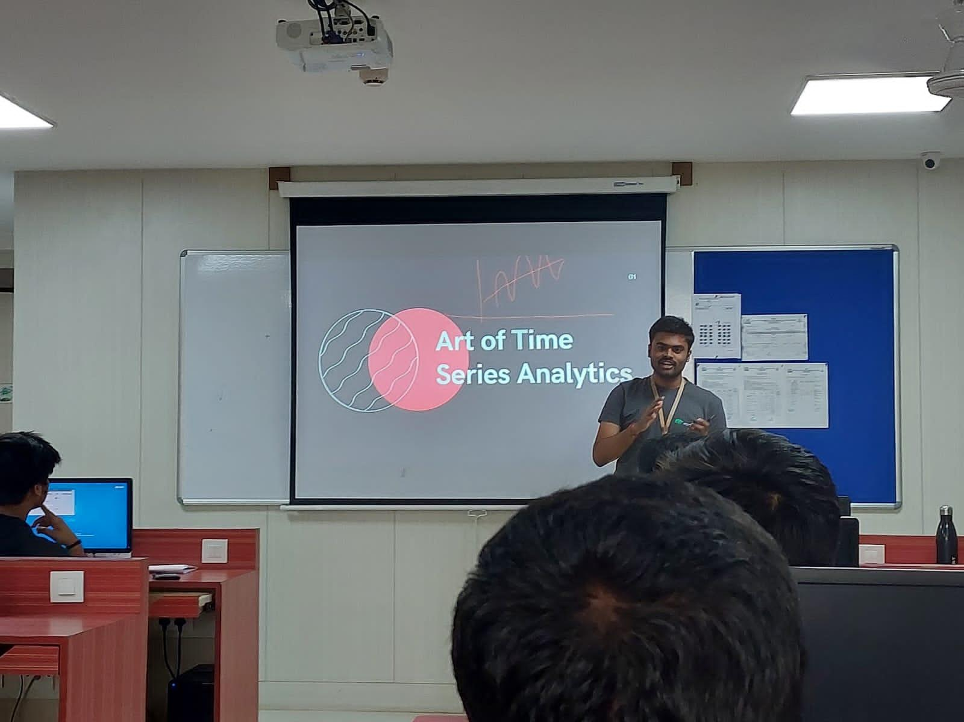

Feedback Analysis:

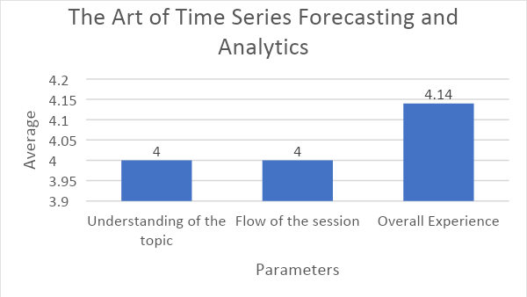

Outcome:

Students were able to understand the fundamentals of time series of analytics.

PO Attained: PO1,PO2,PO3,PO9

Activity 3: Ideathon

Date: 23rd March 2023

Participants: ST and TT Students

Objectives:

To foster creativity and problem-solving skills

To promote collaboration and teamwork

To encourage participants to submit their innovative ideas

Participation Analysis:

Sr. No. | Class | No. of Students
1 | ST | 18
2 | TT | 11
Total : |  | 29

Description:

Super AI Stakeholder Connect organized an Ideathon for AI&ML students. Participants submitted innovative ideas in a PPT format, showcasing creativity and problem-solving skills. Third-year TT students demonstrated 50% implementation, excluding reuse of previous RBL ideas. Collaboration in teams of 1-4 members was encouraged. Standardized PPT template ensured consistent evaluation.

Activity Photo:

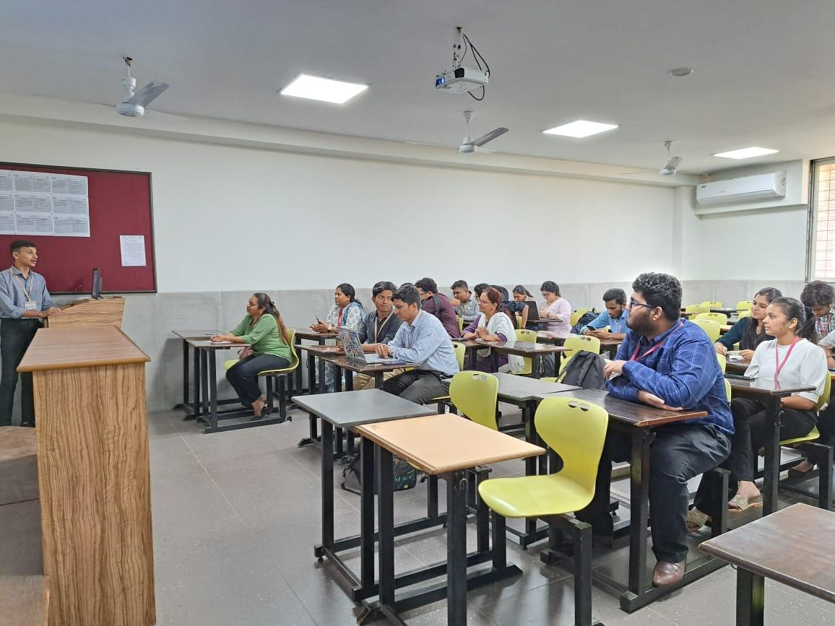

Feedback Analysis:

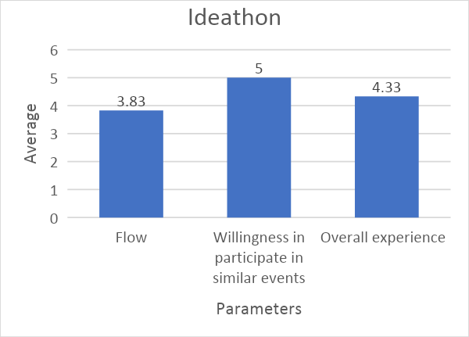

Outcome:
The activity proved to be a captivating experience for the students as they creatively portrayed their perspectives and ideas within the domain.
PO Attained: PO1,PO2,PO3,PO4,PO5,PO6,PO7,PO8,PO9,PO10
Activity 4: Quiz Competition

Date: 20th April, 2023

Time: 4.30 pm onwards

Participants: ST Students

Objectives:

To enhance students' analytical capabilities and cognitive reasoning.

To develop and refine their problem-solving strategies and logical reasoning techniques.

Description:

The Quiz competition organized by Super AI Stakeholder Connect successfully challenged students' problem-solving abilities and enhanced their analytical capabilities and cognitive reasoning skills. The event, conducted online via Google Form, provided an accessible platform for students to showcase their problem-solving abilities. Participants enthusiastically registered and actively engaged in solving a set of challenging multiple-choice and fill-in-the-blanks questions.

Participation Analysis:

Sr. No. | Class | No. of Students
1 | ST | 14
Total : |  | 14

Feedback Analysis:

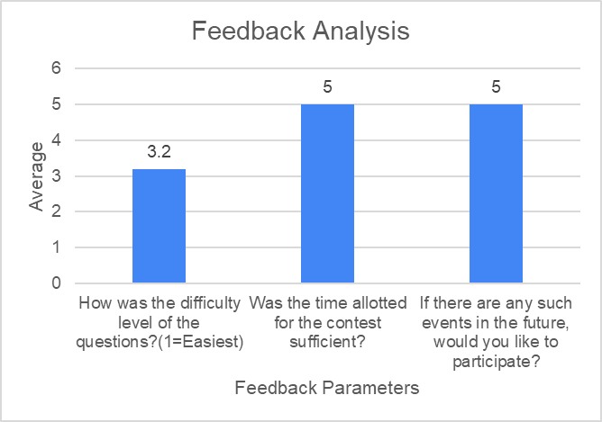

Outcome:
Students were able to enhance their problem-solving abilities and cognitive reasoning skills through active participation in the Quiz competition.
PO Attained:PO1,PO2,PO8,PO9
Activity 5: Expert session on emerging tools in AI.

Date - 15/05/2023

Time - 7:30pm

Participants: ST and TT Students

Objectives:

To provide attendees with insights into emerging tools in AI

To gain practical knowledge and understand how these emerging tools can be implemented in real-world scenarios.

To familiarize participants with the features, applications, and advantages of these tools, enabling them to stay updated with the latest advancements in AI.

Description:

Super AI Stakeholder Connect recently organized an Expert session on emerging tools in AI. The session aimed to provide attendees with valuable insights into the latest advancements in AI technology. Topics covered included BDA-Data Lake and AIP-Mean stack, offering practical knowledge and demonstrating how these tools can be implemented in real-world scenarios. Led by an experienced industry professional, the session provided a comprehensive understanding of the applications and benefits of these emerging AI tools.

Participation Analysis:

Sr. No. | Class | No. of Students
1 | ST | 07
2 | TT | 11
Total : |  | 18

Activity Photo:

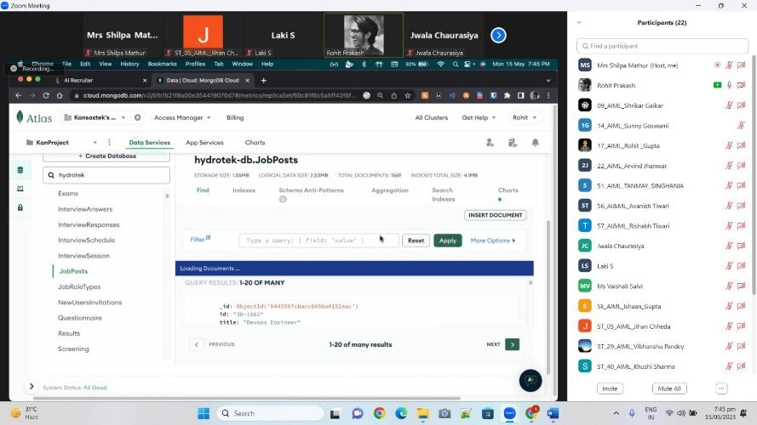

Feedback Analysis:

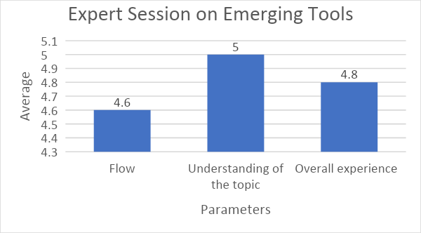

Outcome:

Students were able to enhance their knowledge in the field and gain valuable insights into the rapidly evolving AI landscape.
PO Attained:PO1,PO2,PO3,PO5

Prepared By
Mrs Shilpa Mathur Dr.Megharani Patil
Faculty Coordinator Convener
Assistant Professor AI&ML I/C HOD AI&ML

